**SELF ORGANIZING MAPS**

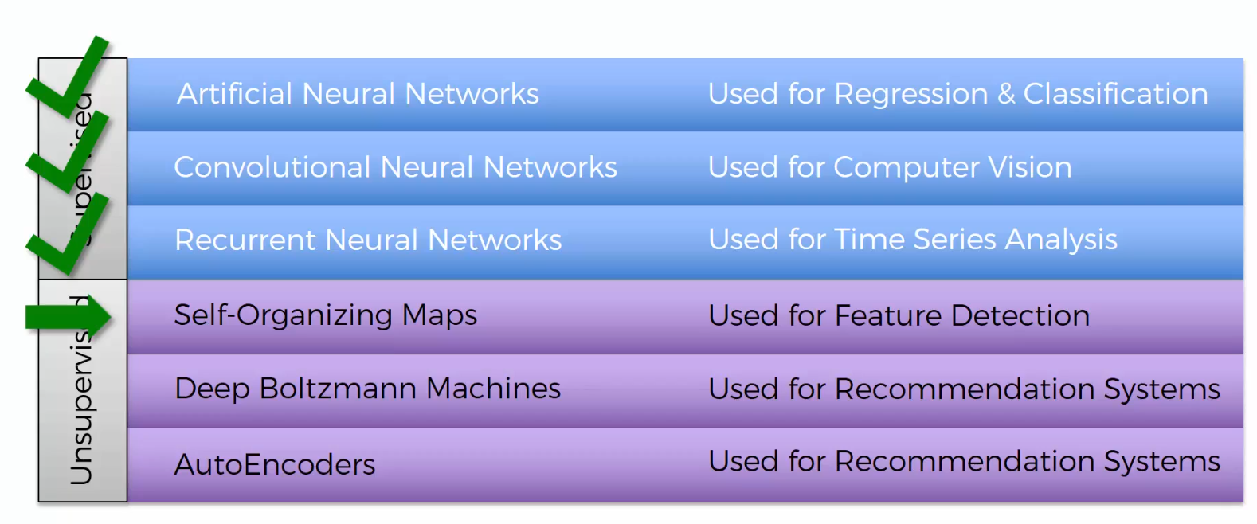

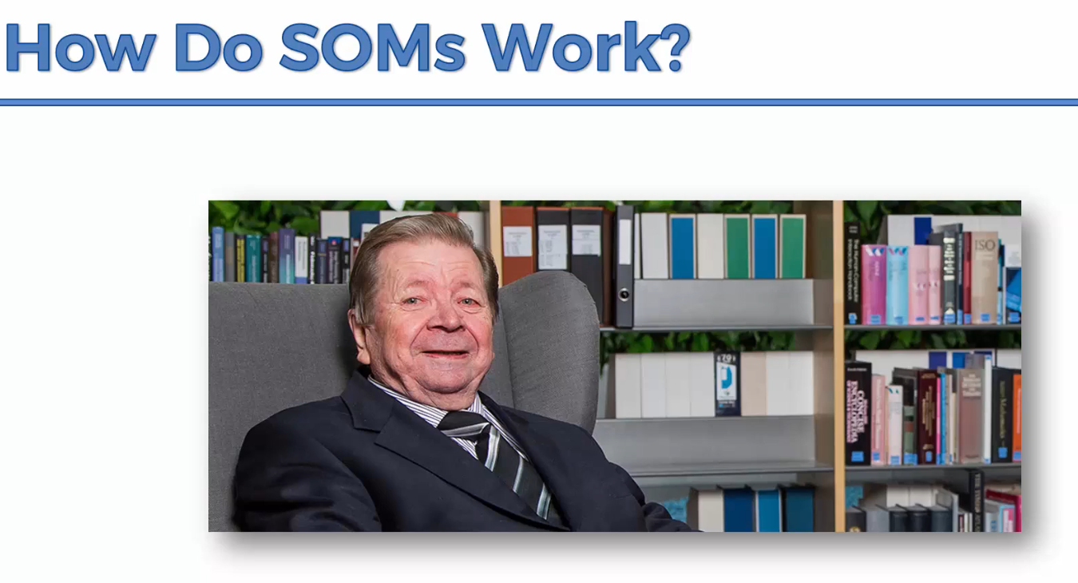

The SOM was introduced by the Finnish professor Teuvo Kohonen in the 1980s and therefore is sometimes called a Kohonen map or Kohonen network.

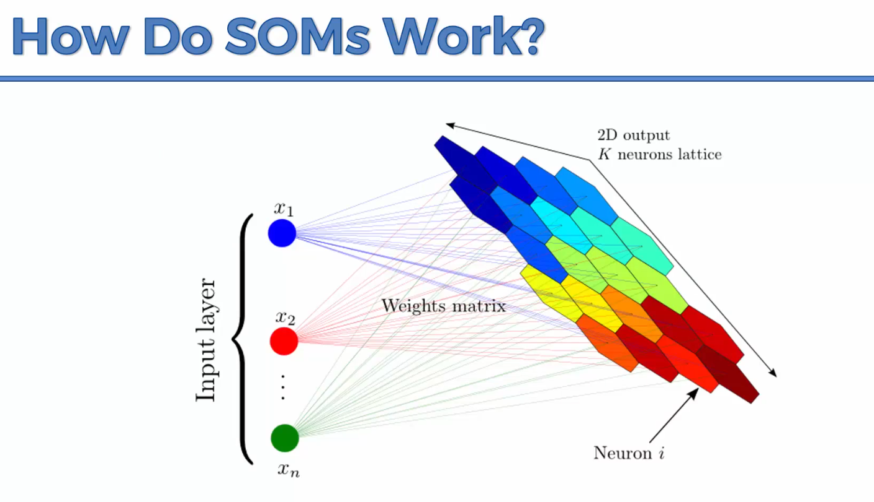

They are used for dimensionality reduction. You can use them in astronomy. They take a multidimensional dataset (lots and lots of columns) and create a 2D representation of your dataset.

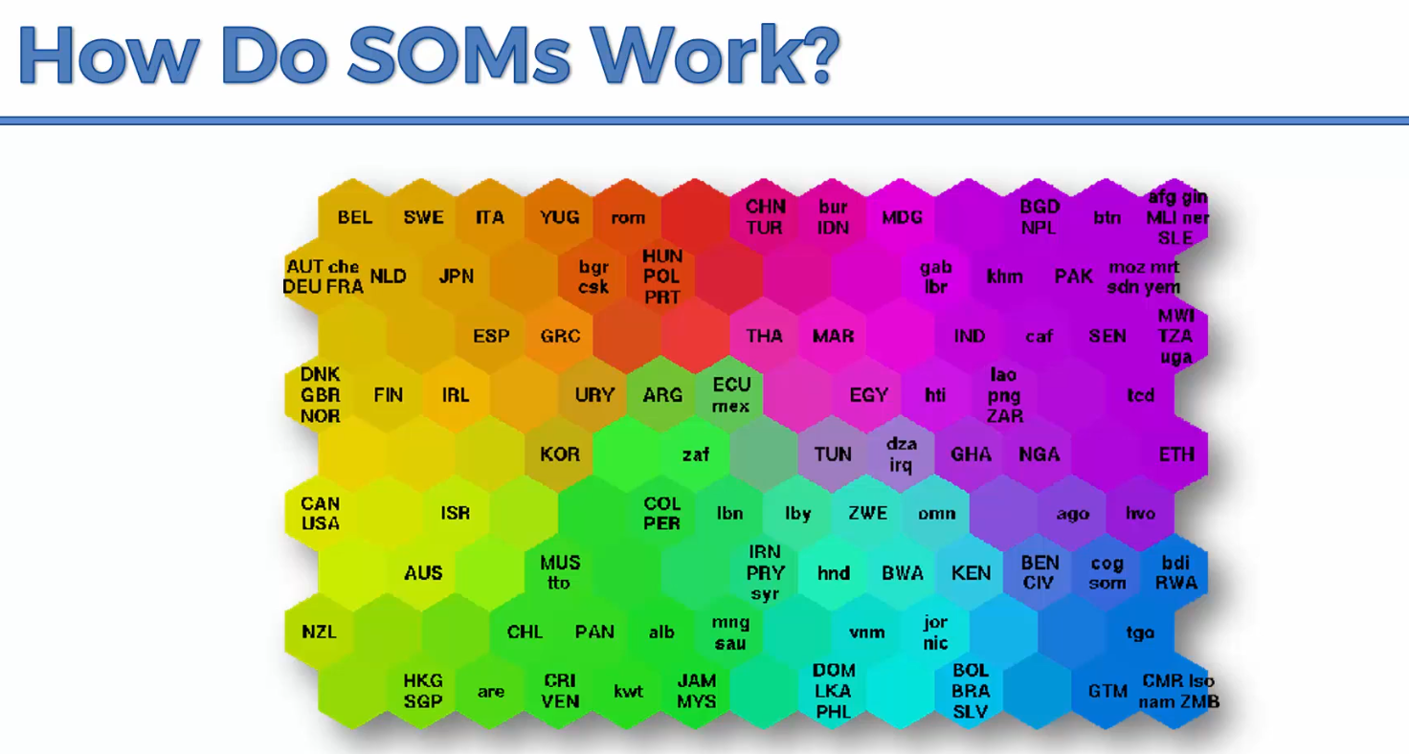

This is a SOM showcasing the different states of prosperity and poverty in different countries. They have been put in different clusters based on 39 indicators. The SOM does this in an unsupervised manner.

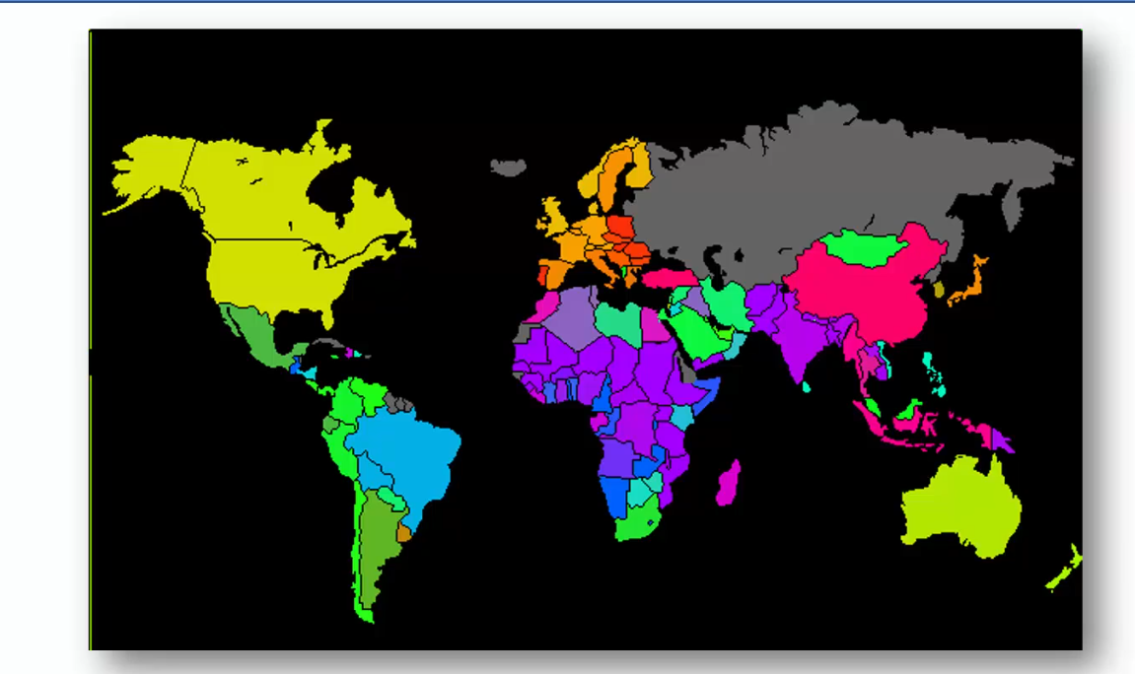

You can then put it in a world map.

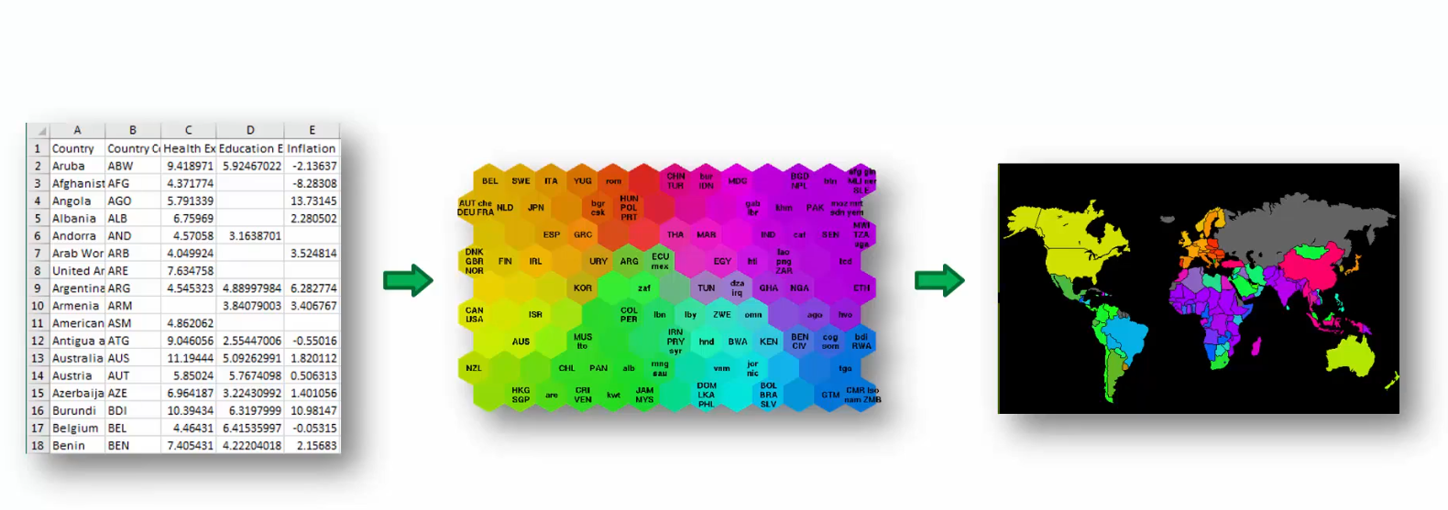

**Additional Reading**

<http://www.ai-junkie.com/ann/som/som1.html>

<https://www.visualcinnamon.com/2013/07/self-organizing-maps-creating-hexagonal/>

**K Means Clustering**

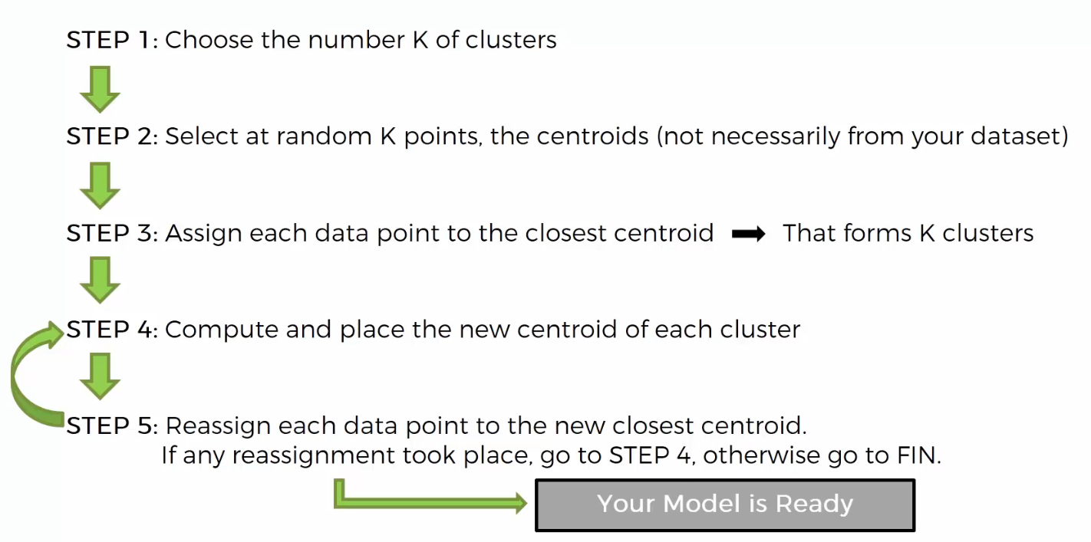

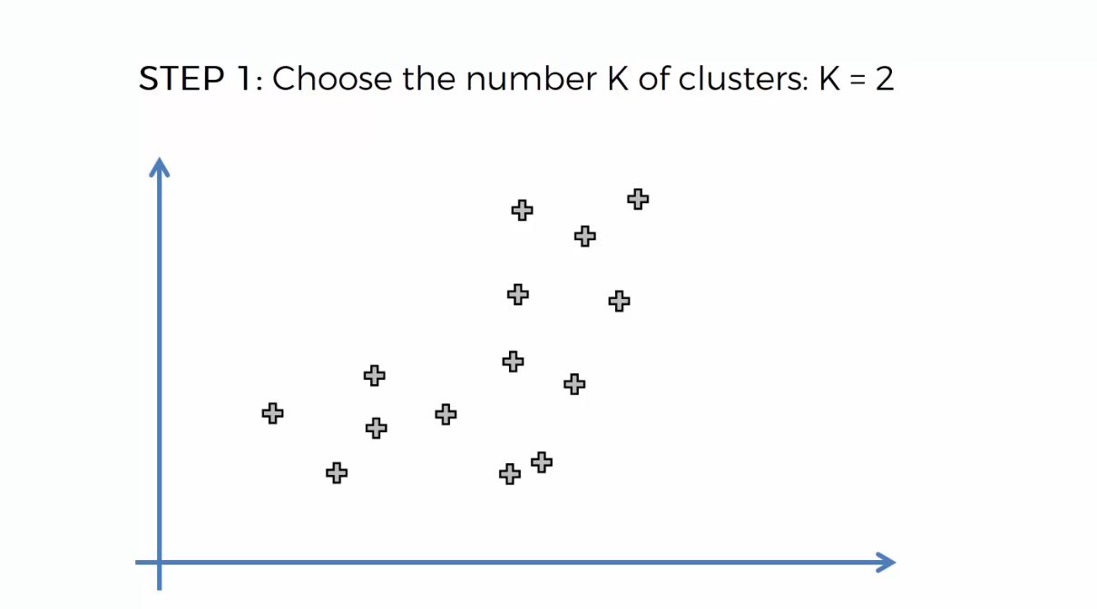

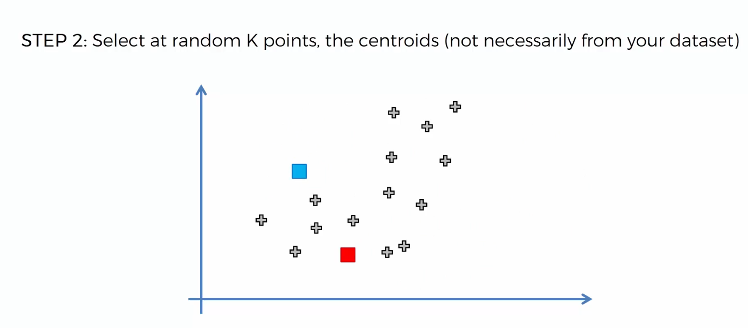

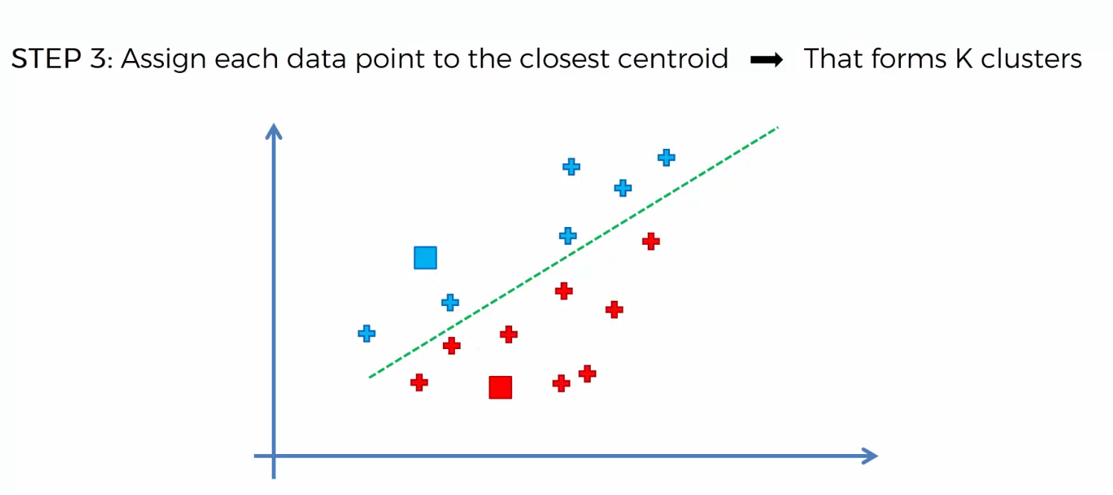

Above we’re using Euclidean distance.

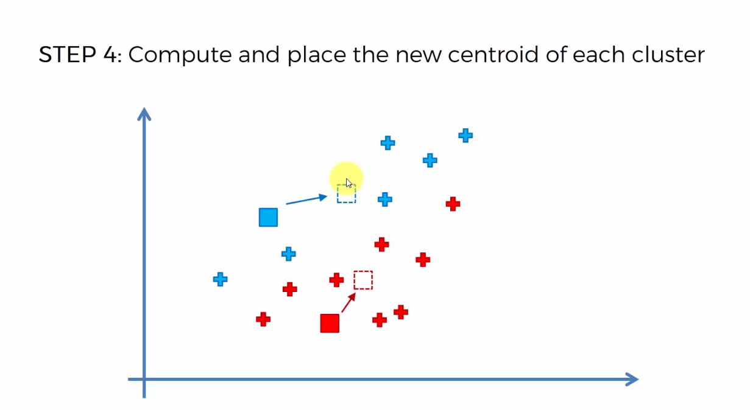

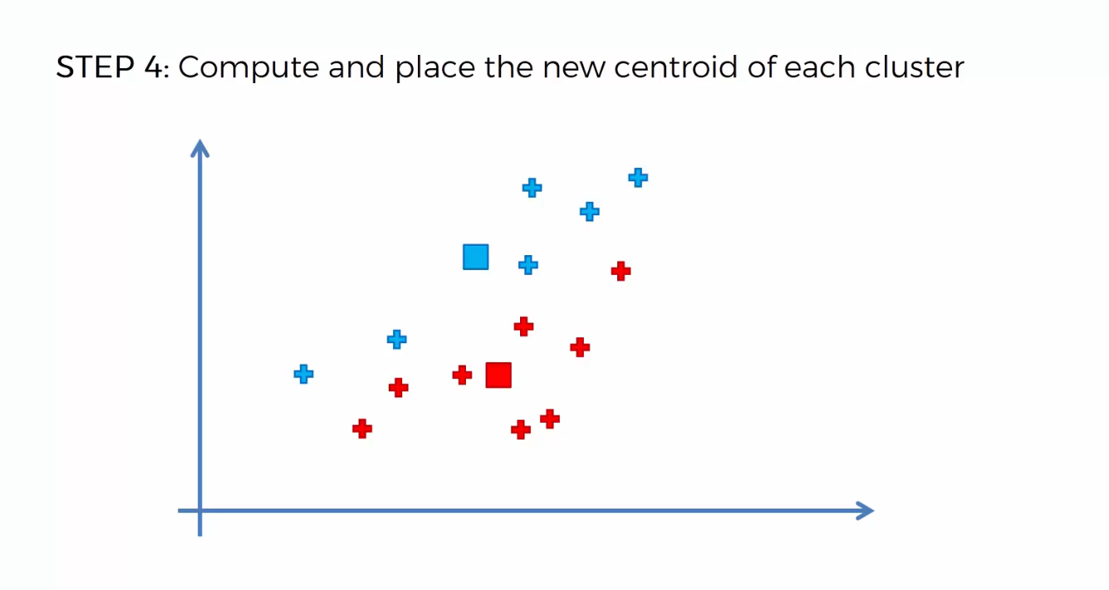

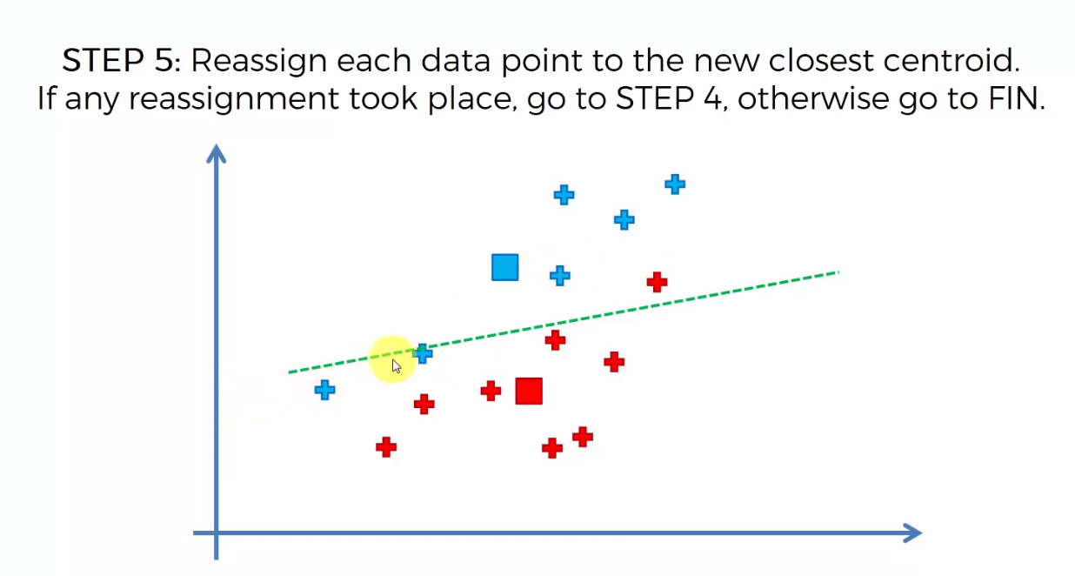

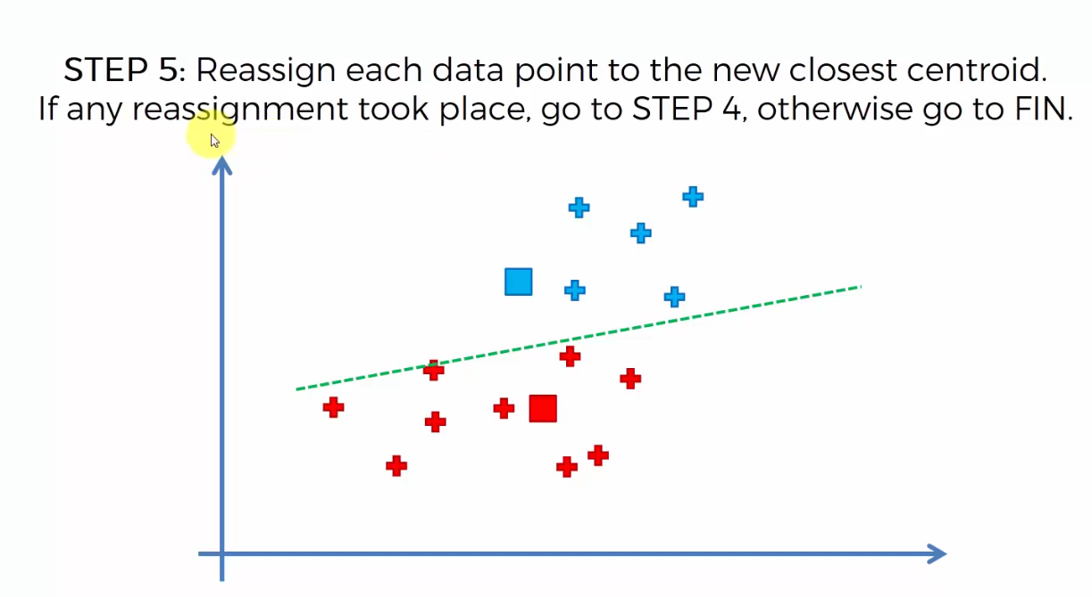

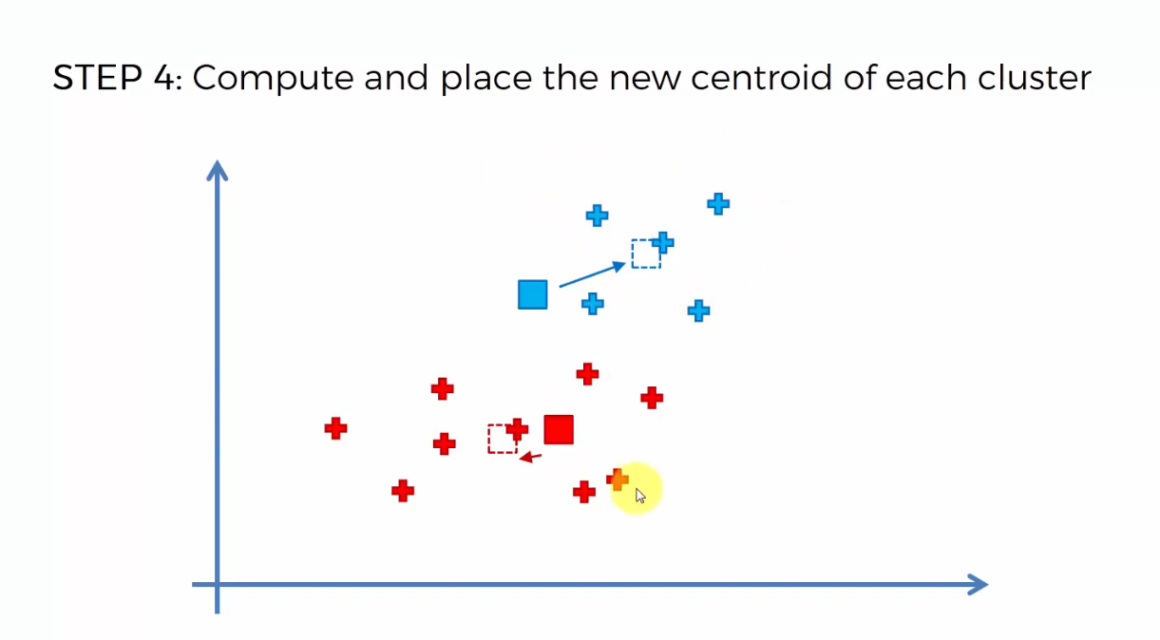

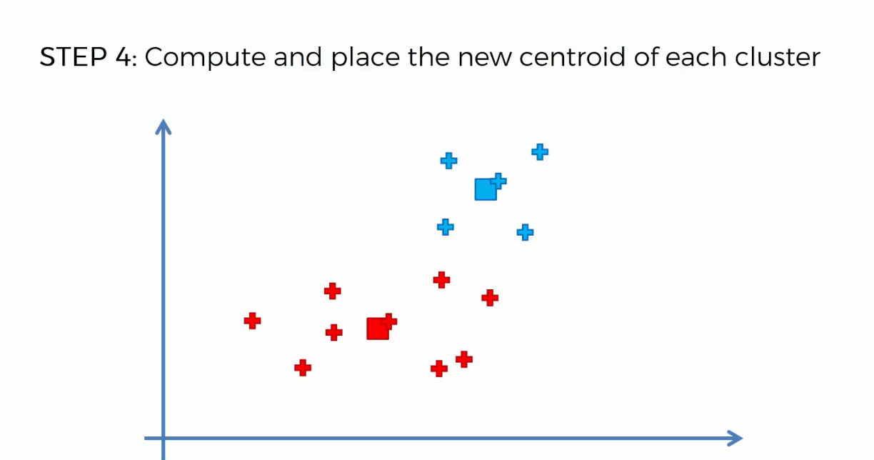

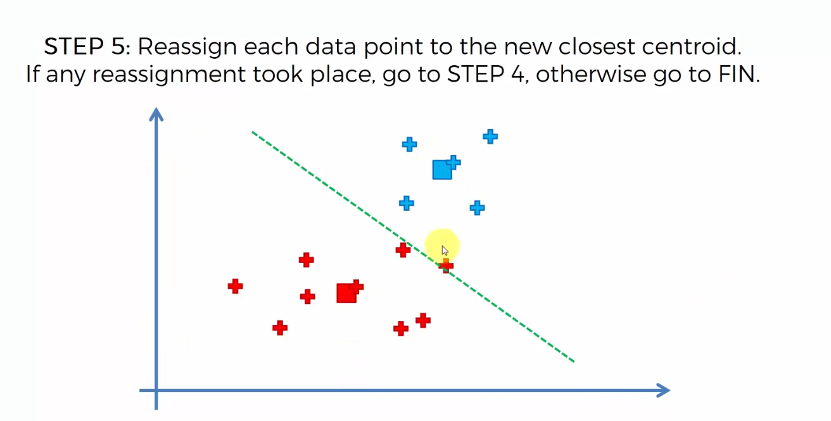

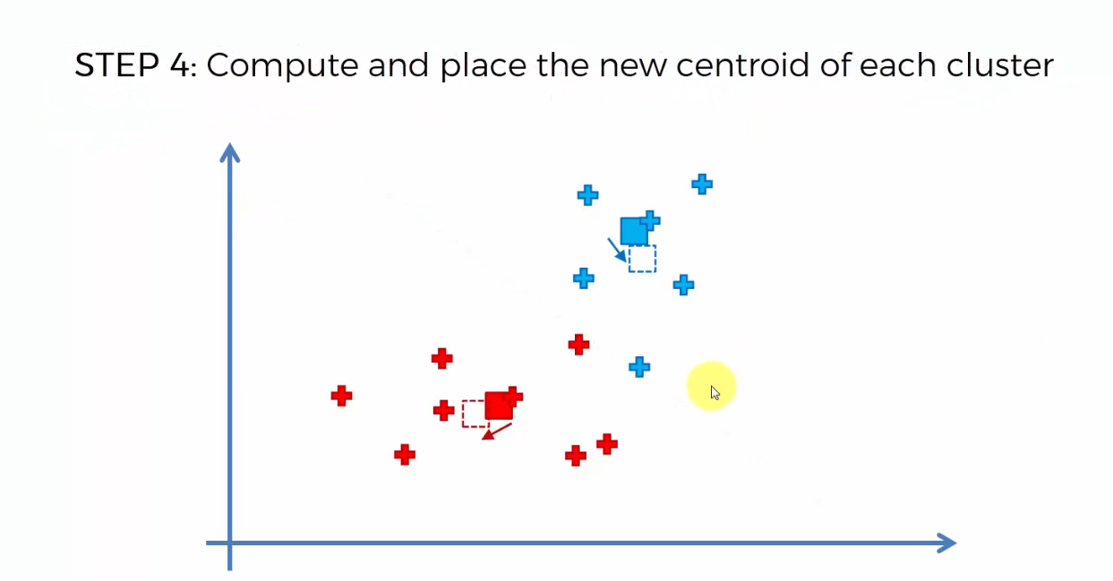

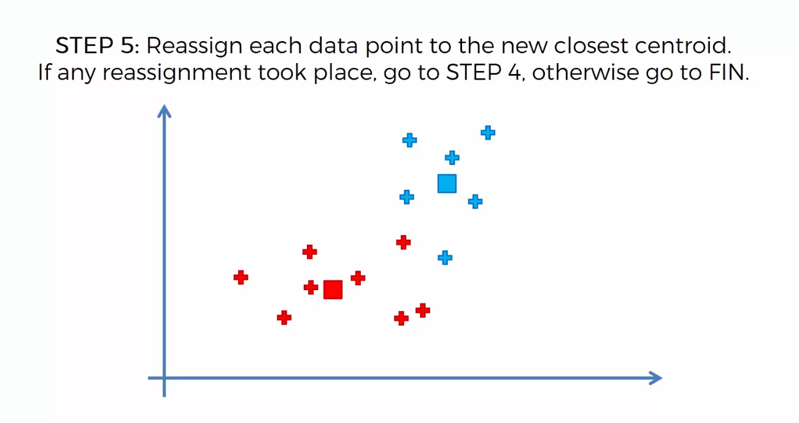

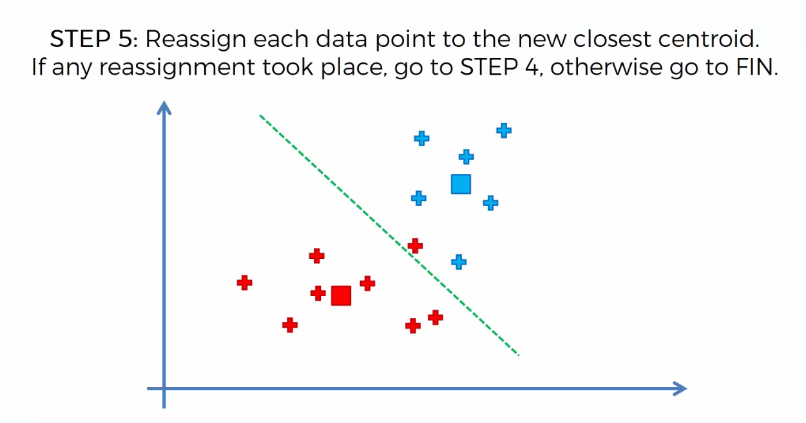

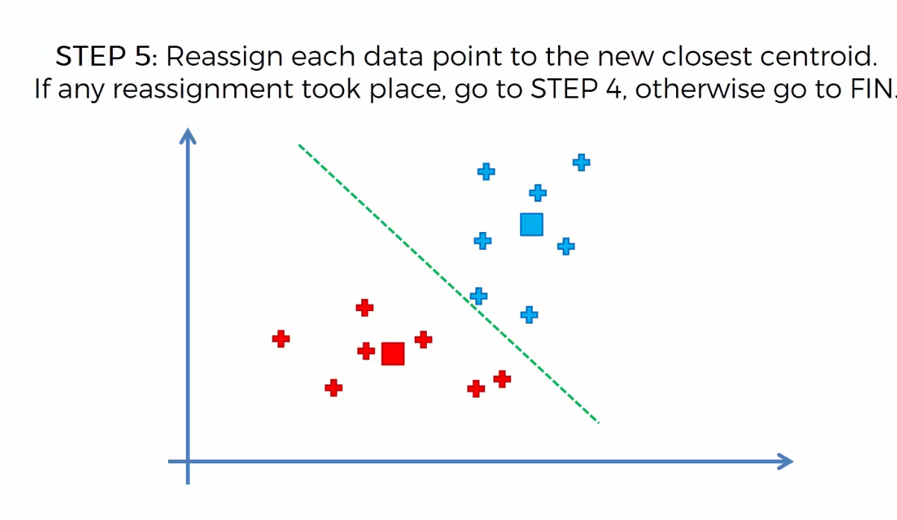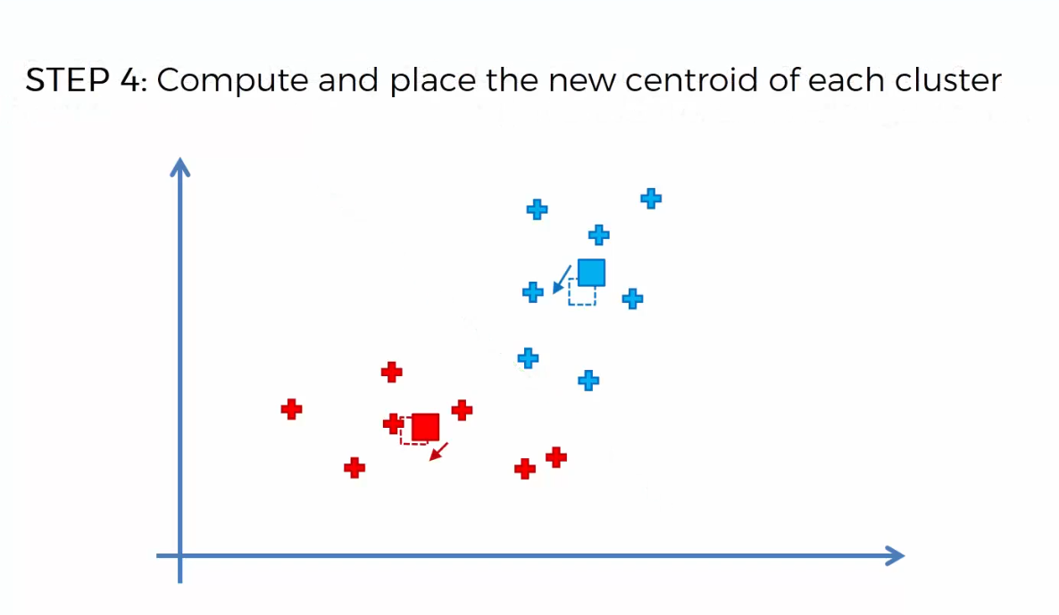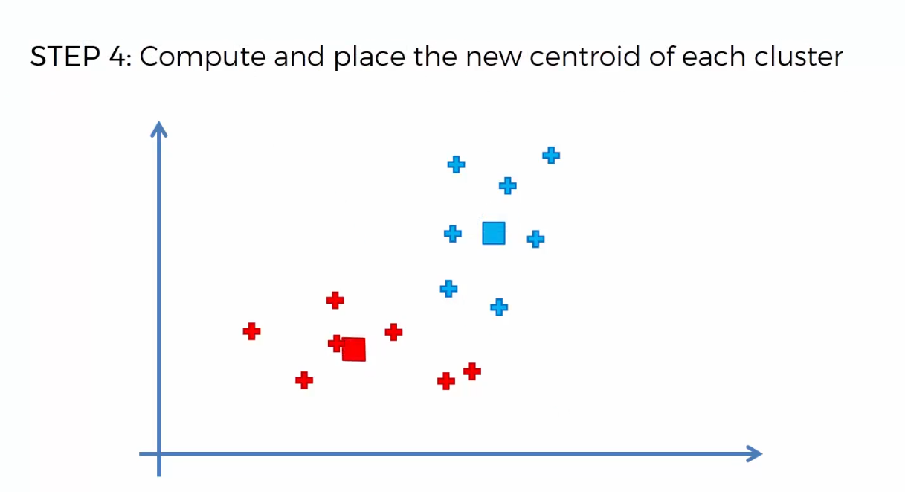

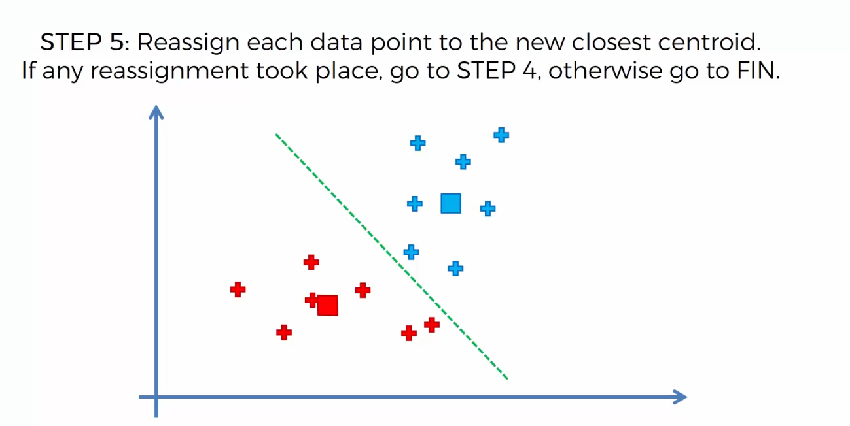

Hence here no reassignment has taken place so we finish the algorithm ends here.

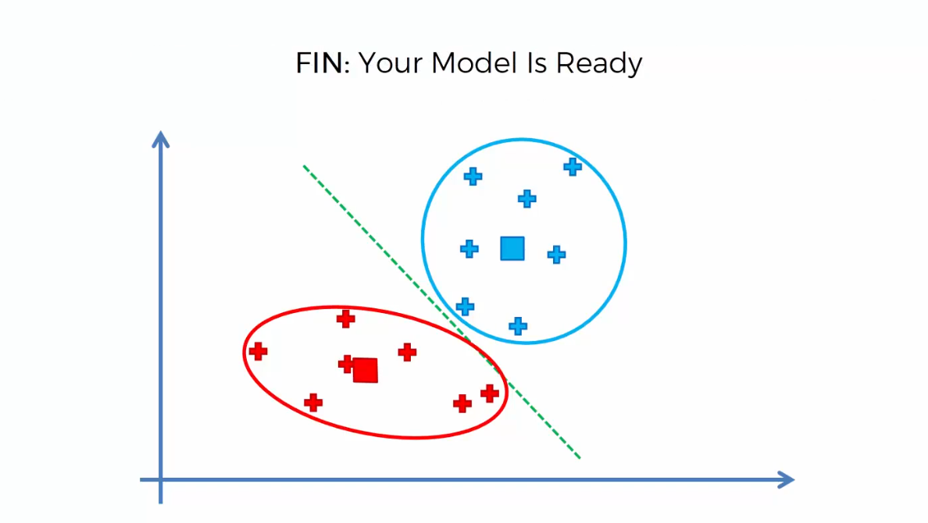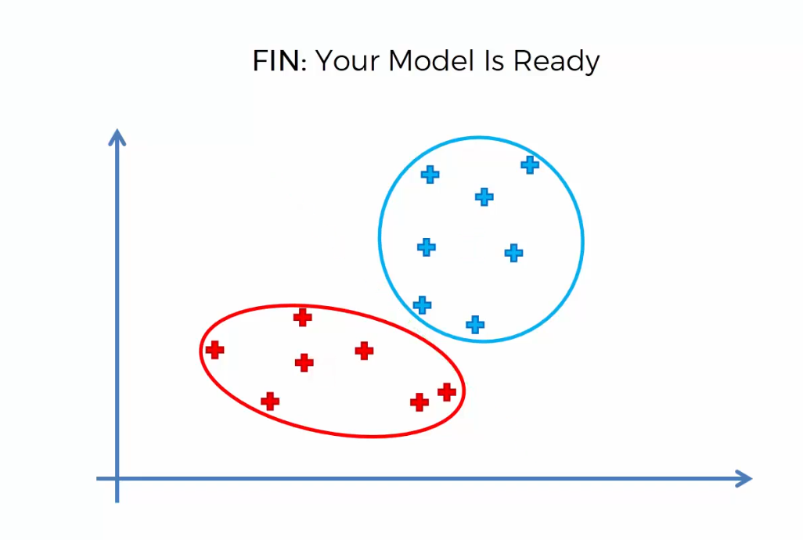

**How Do Self Organizing Maps Learn?**

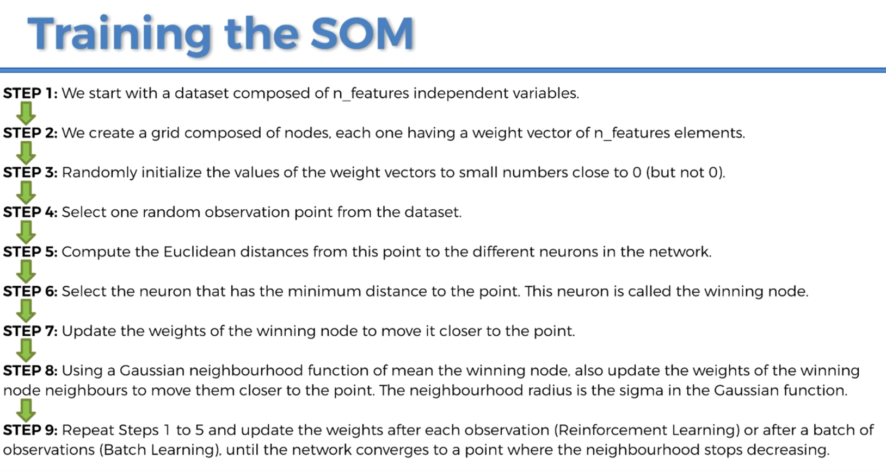

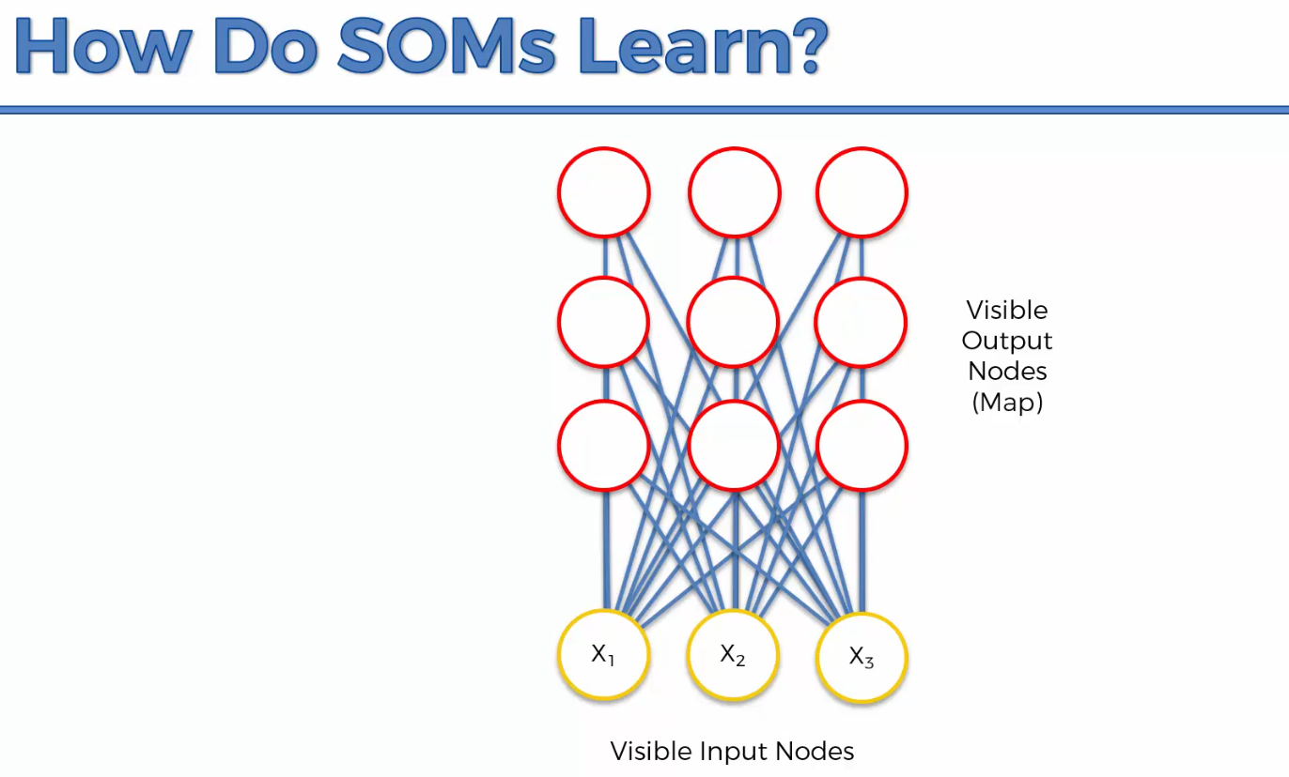

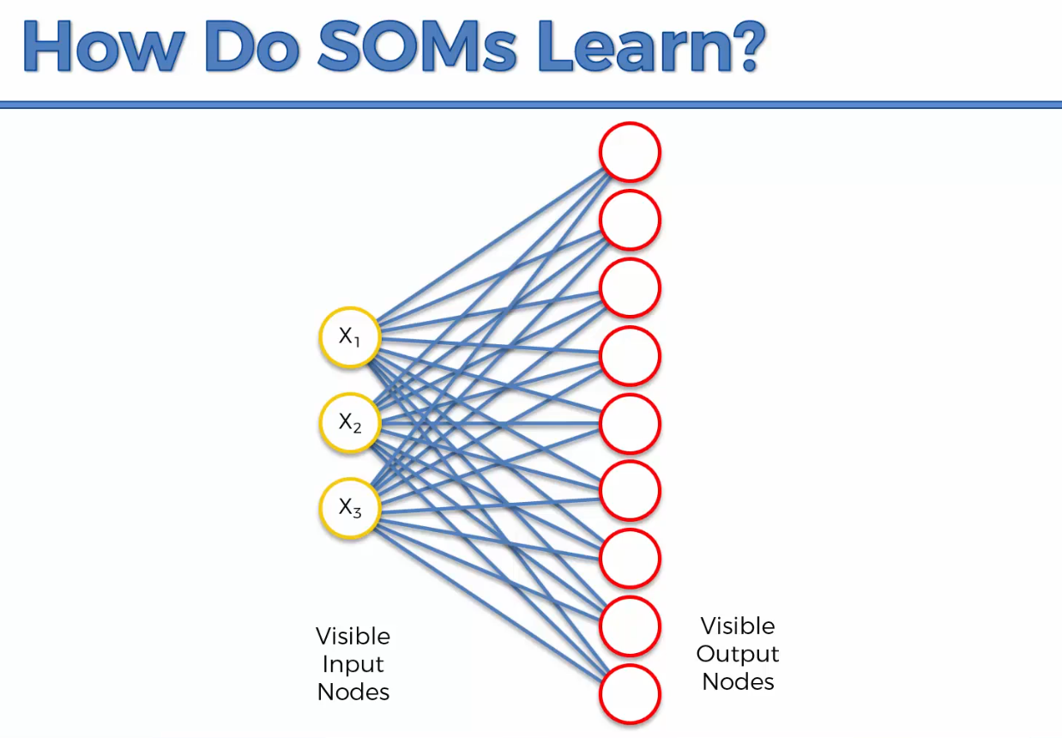

Self organizing maps are actually easy easier than neural networks but are completely different from them as well.

Weights in SOMs are used completely differently than neural networks.

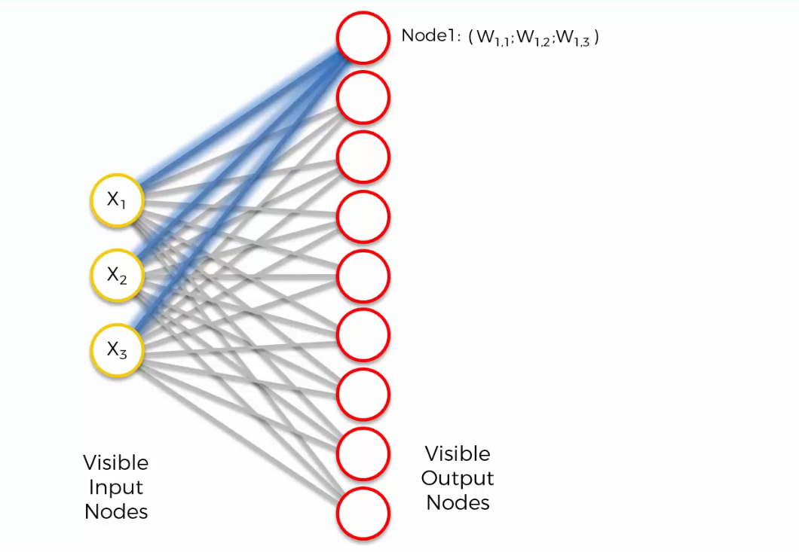

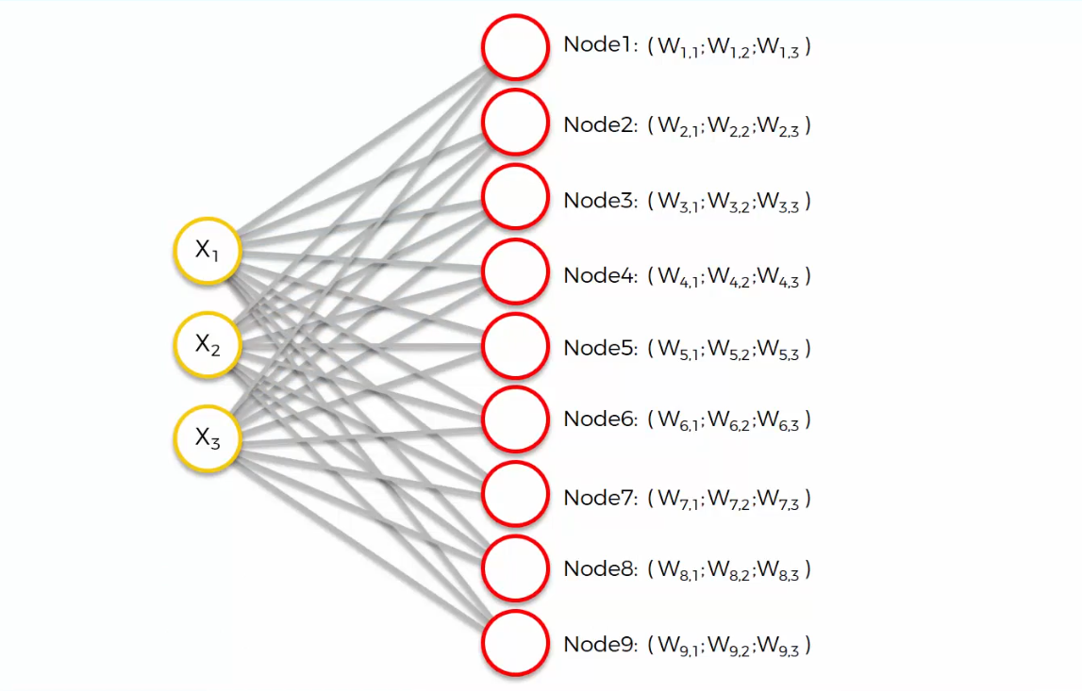

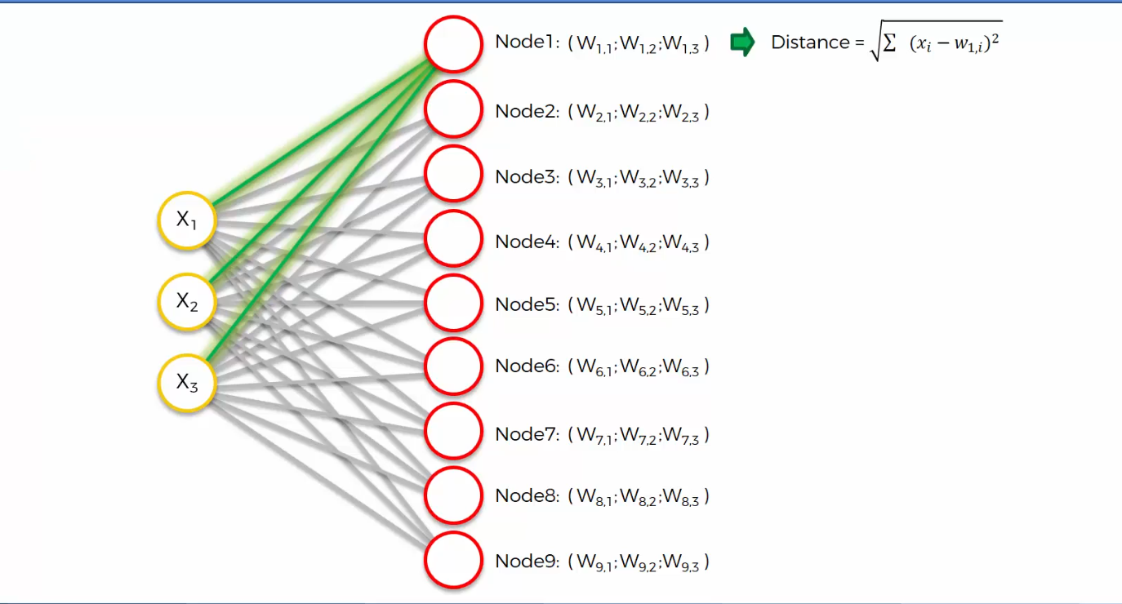

Above is the distance between row 1 and node 1 in our data set.

Closest one is node 3, and it’s called the BMU i.e. Best Matching Unit for row 1.

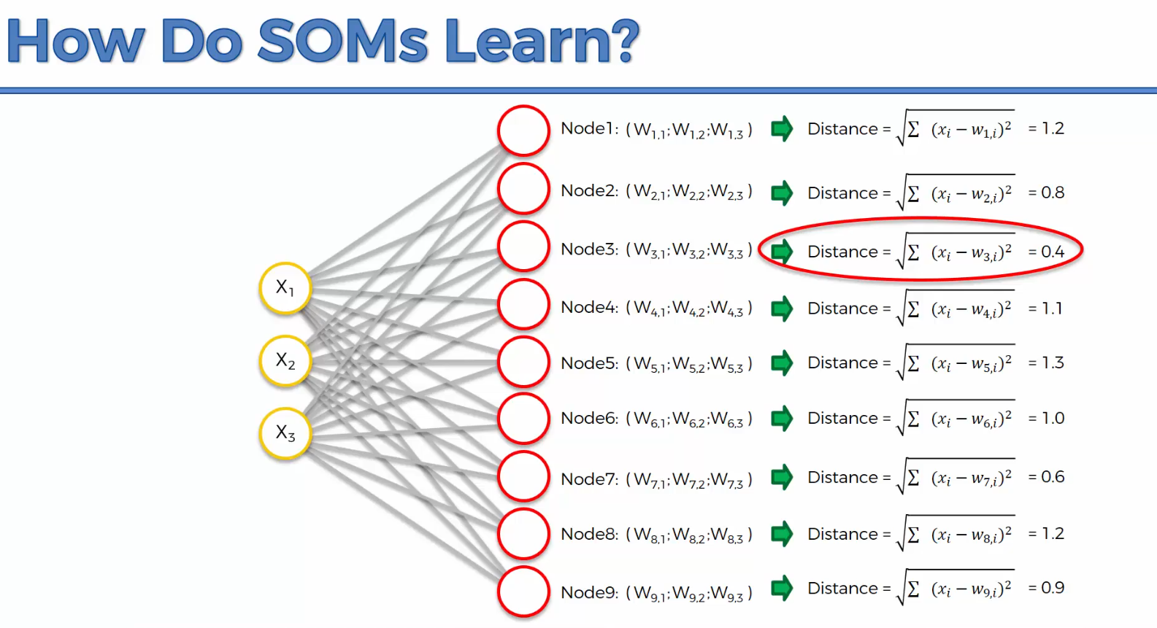

The BMU is identified and the weights are updated in the SOM

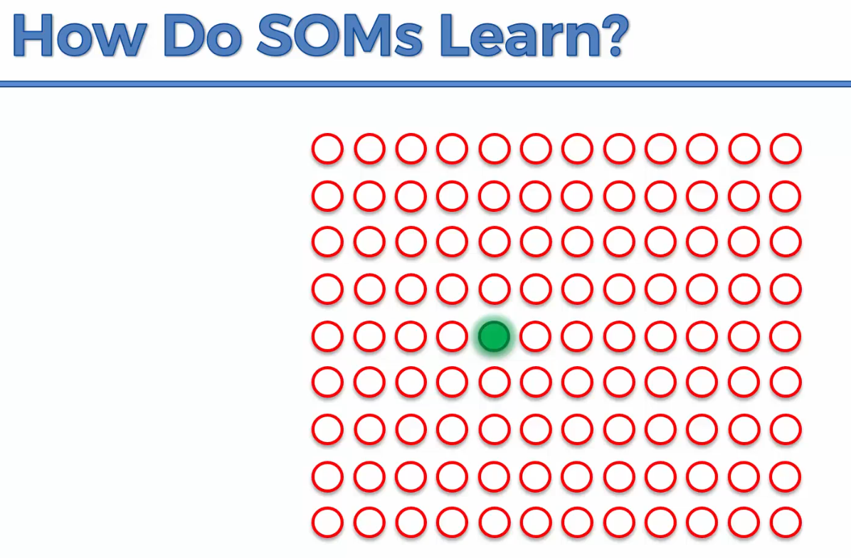

The SOM is basically coming closer to our dataset

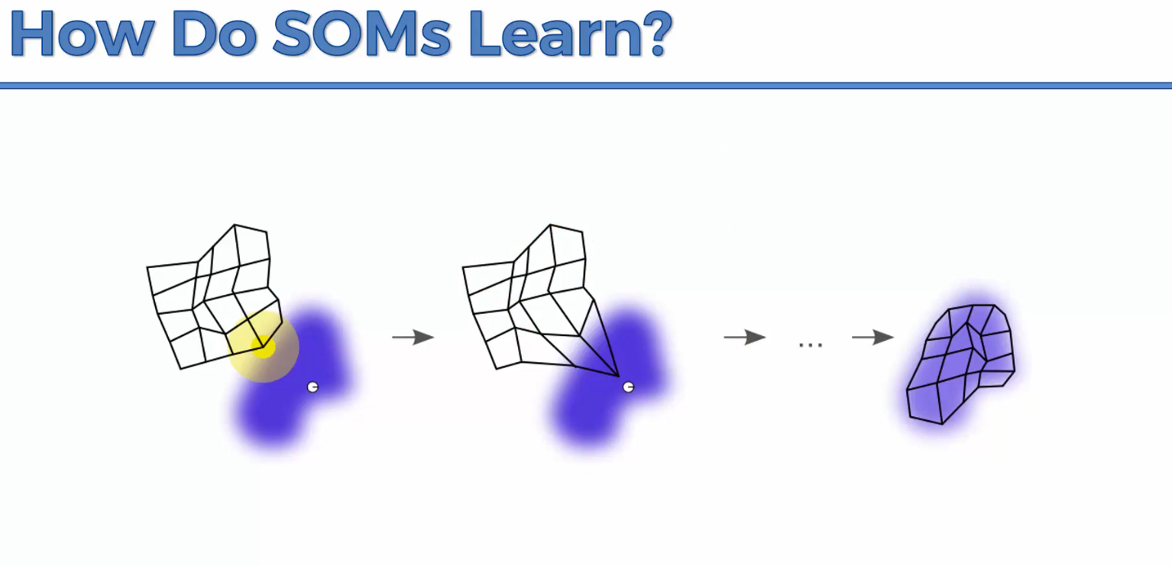

Every single node in the radius will have their weights updated for the SOM to get closer to the nodes.

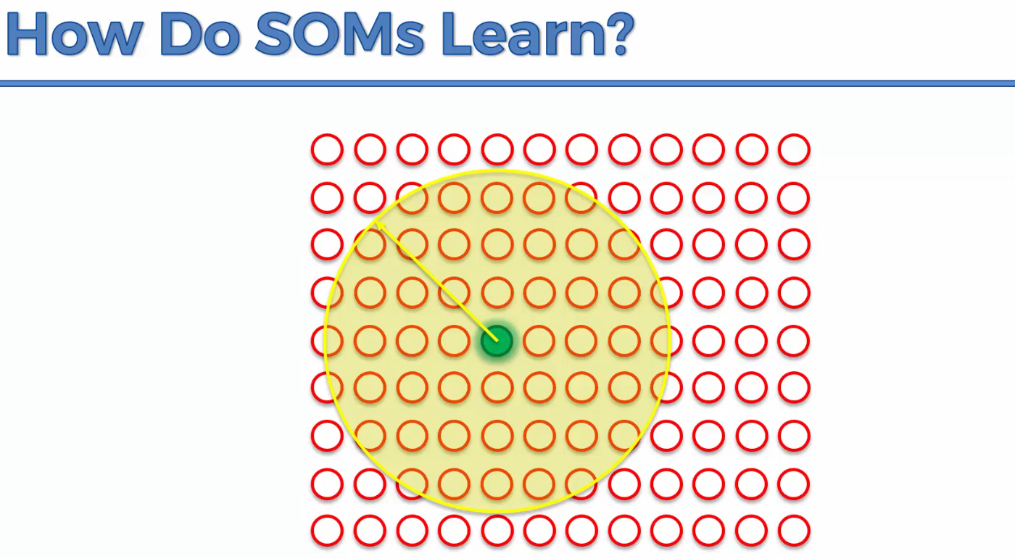

Let’s say row number two had its Best Matching Weight at the Blue spot

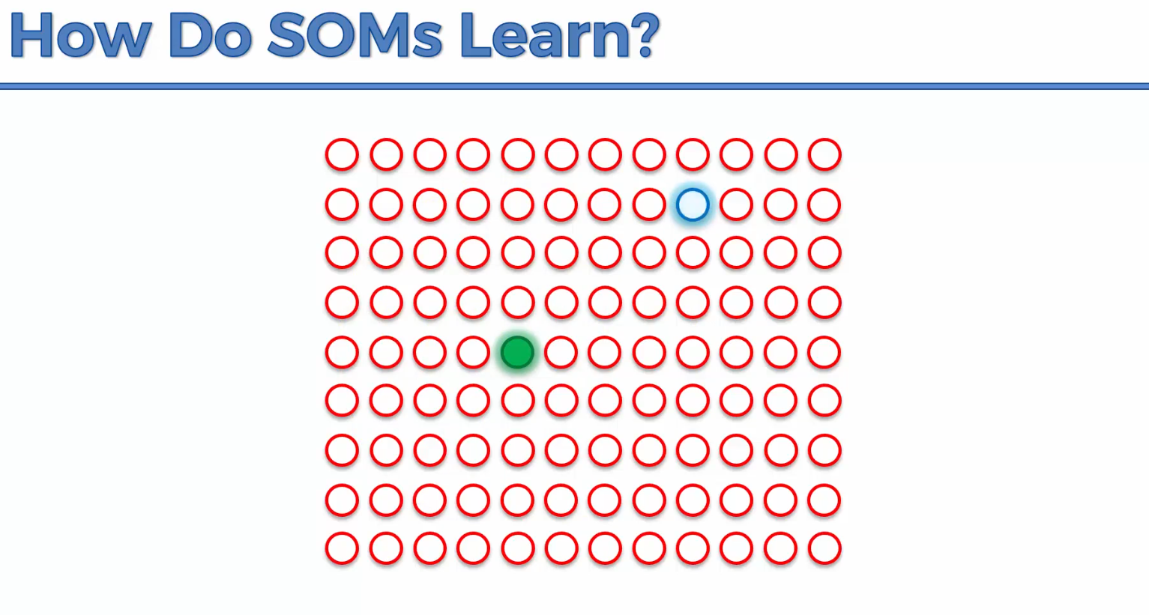

Everything in the radius will be updated to the point that it matched up to

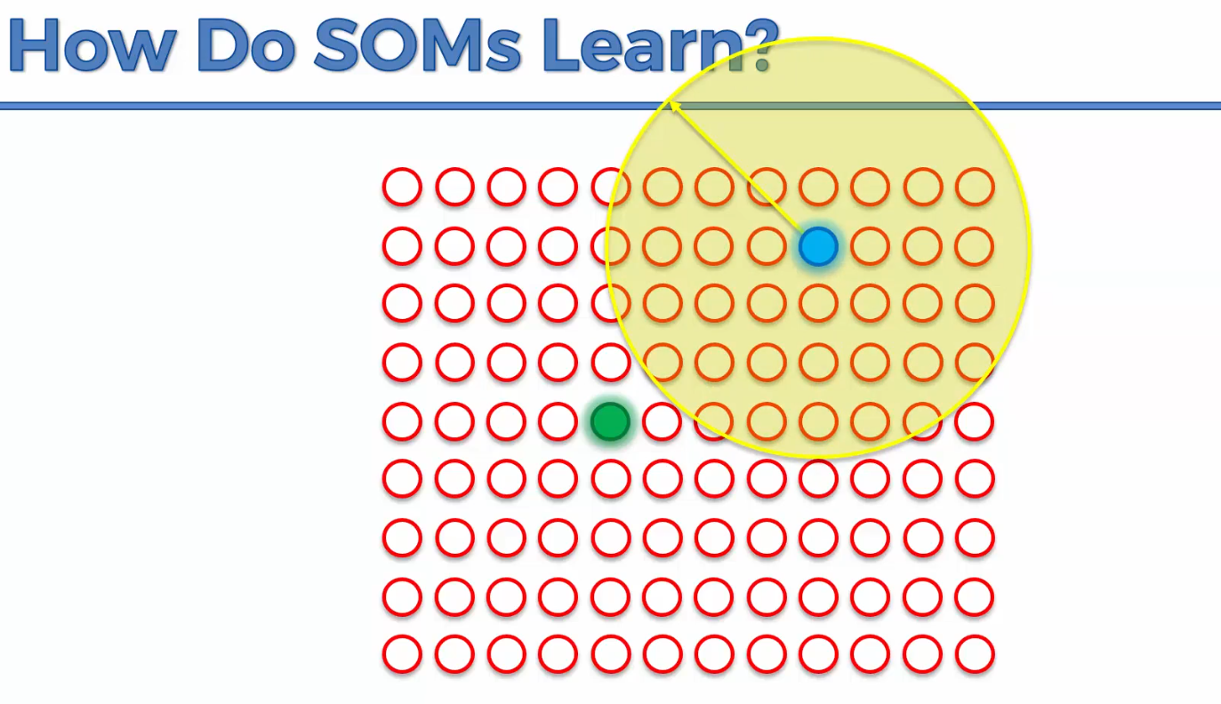

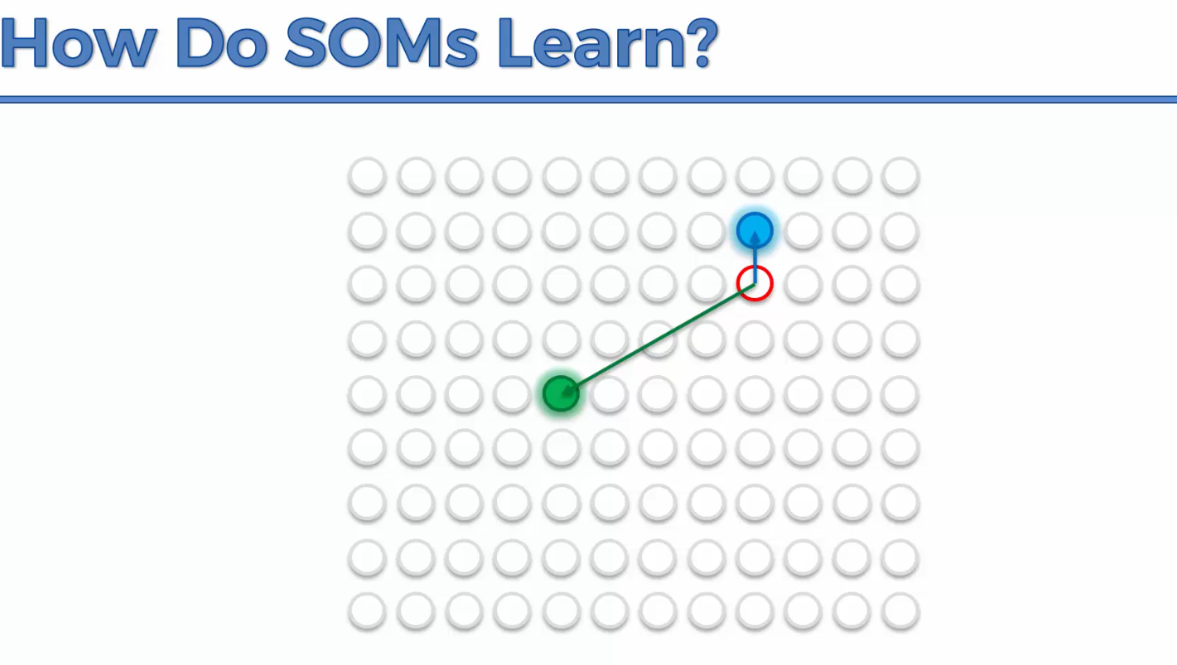

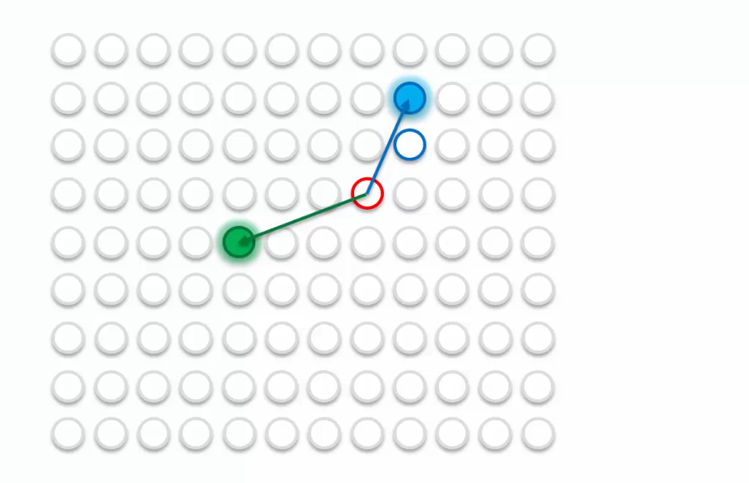

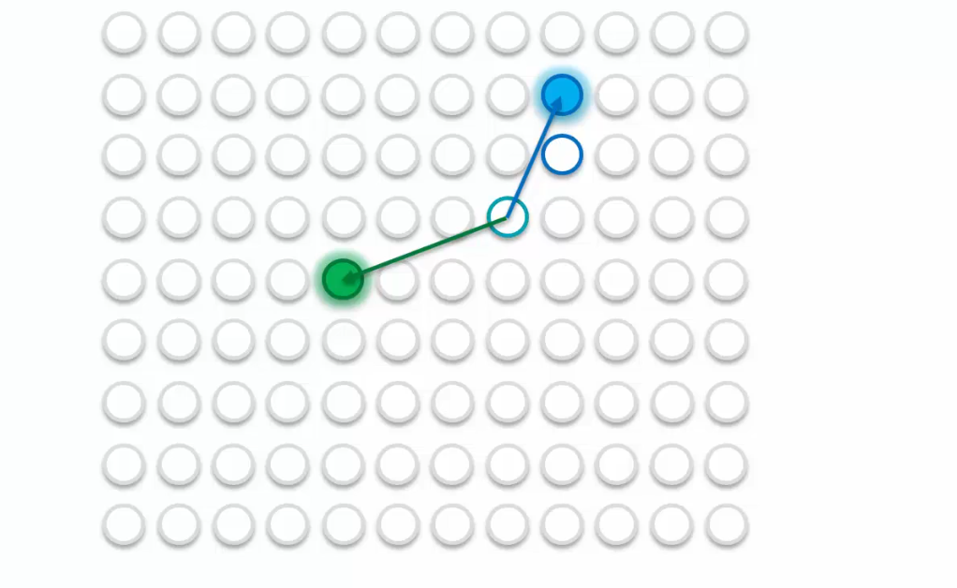

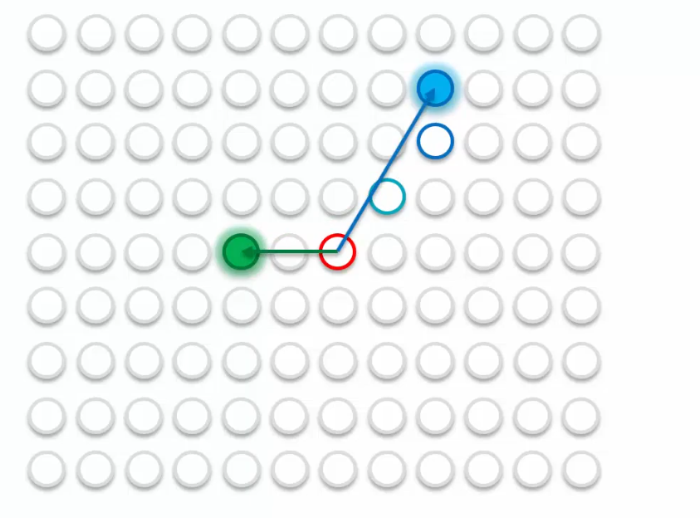

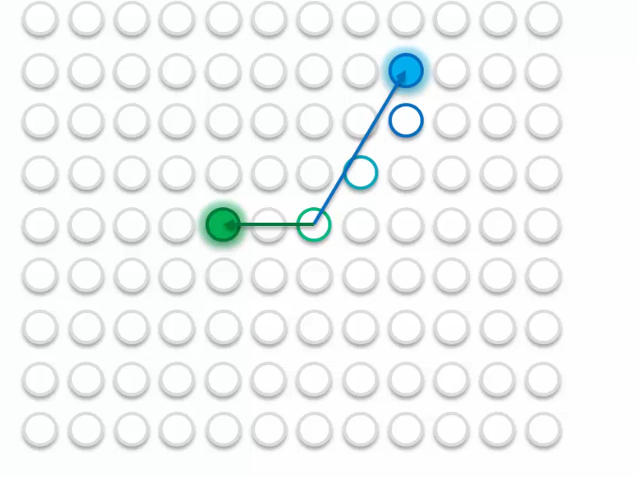

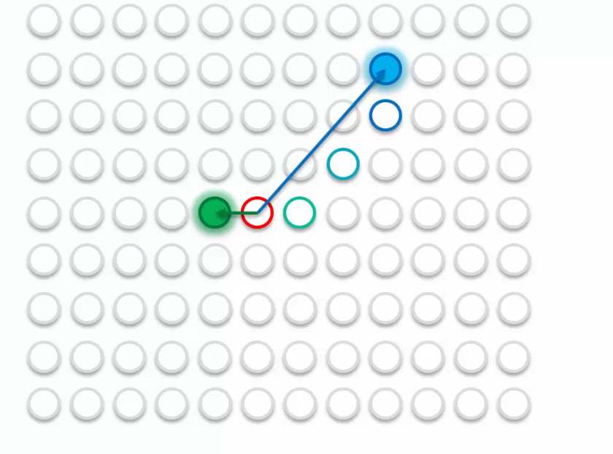

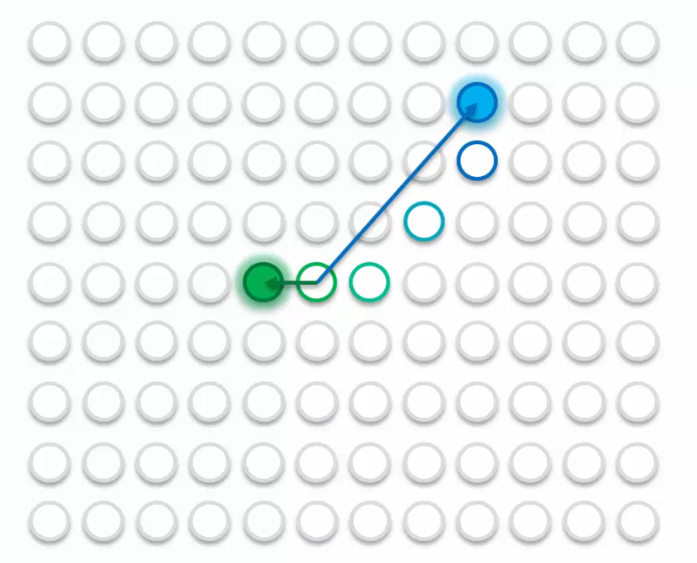

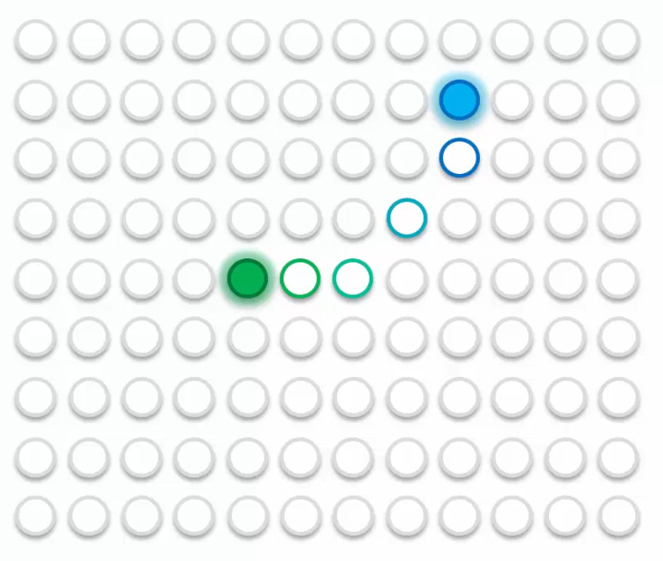

Let’s look at 5 BMUS

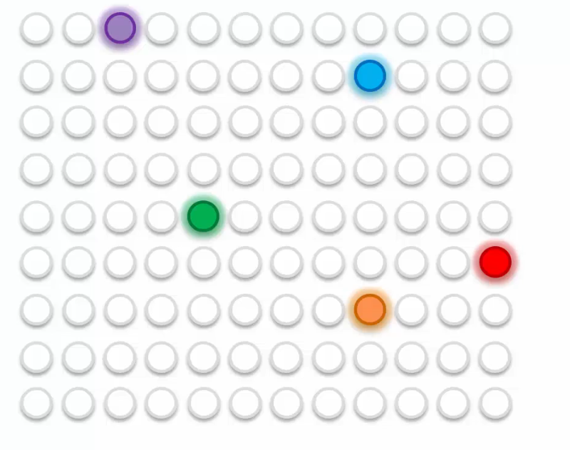

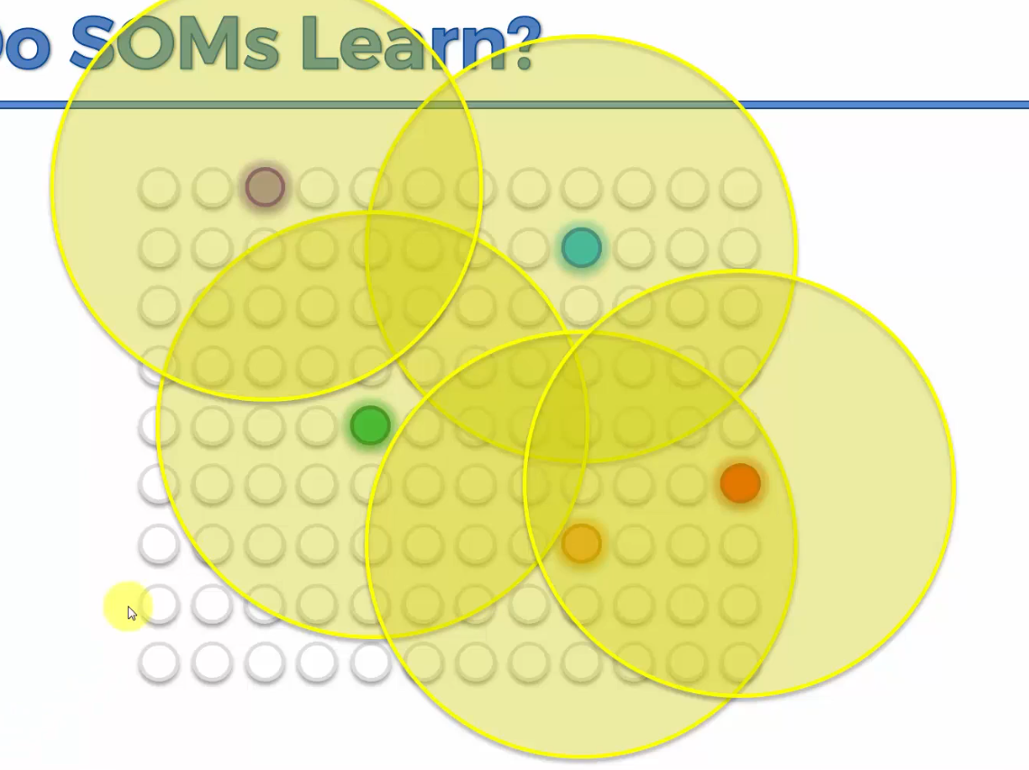

This is just an illustration but usually at the start the radius encompasses everything.

In the next epoch, your radius becomes smaller;  
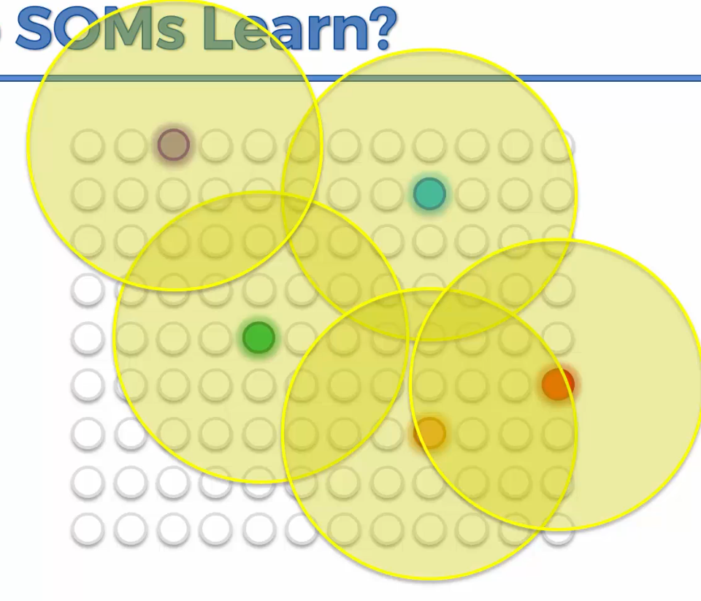

And then again;

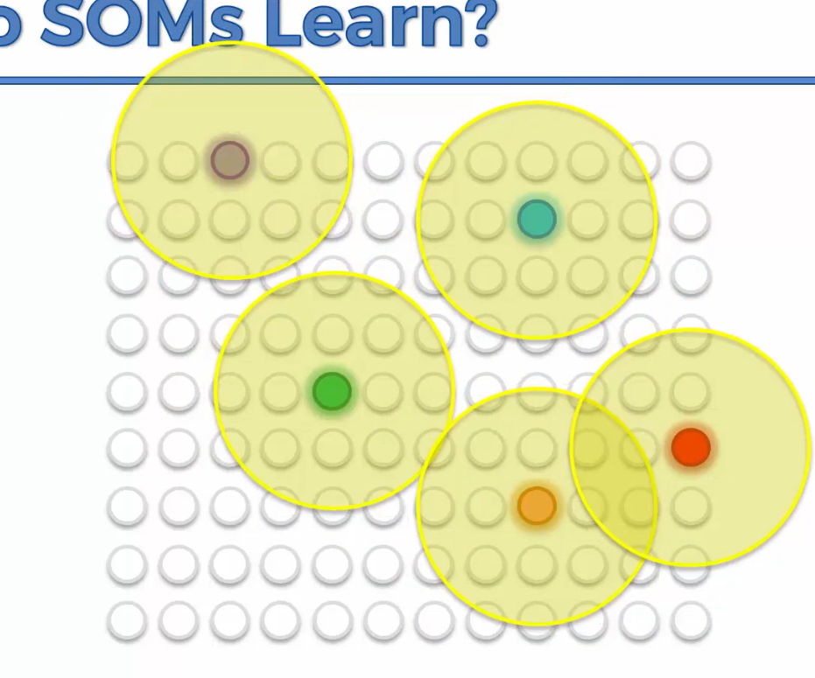

Then at the end it’ll be like this;

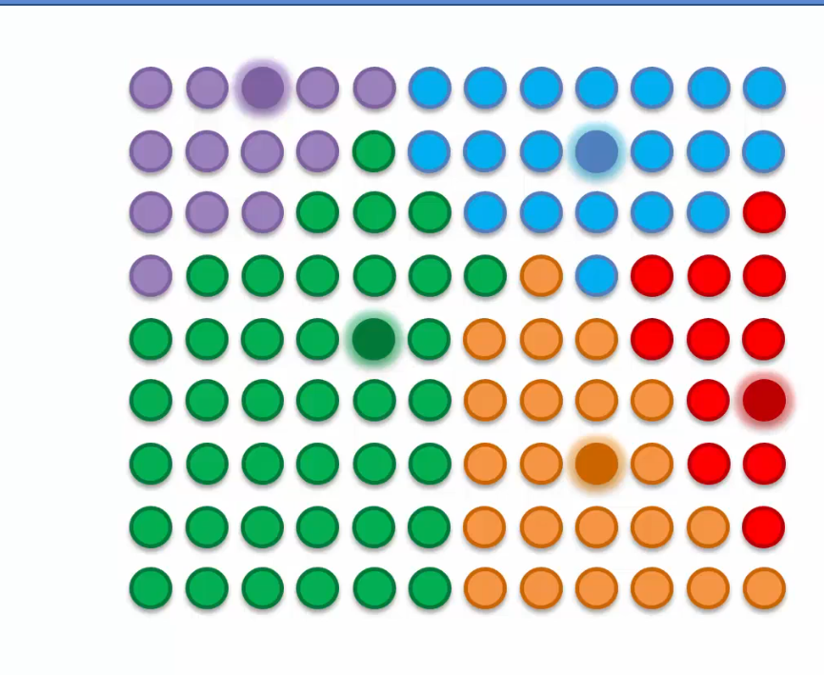

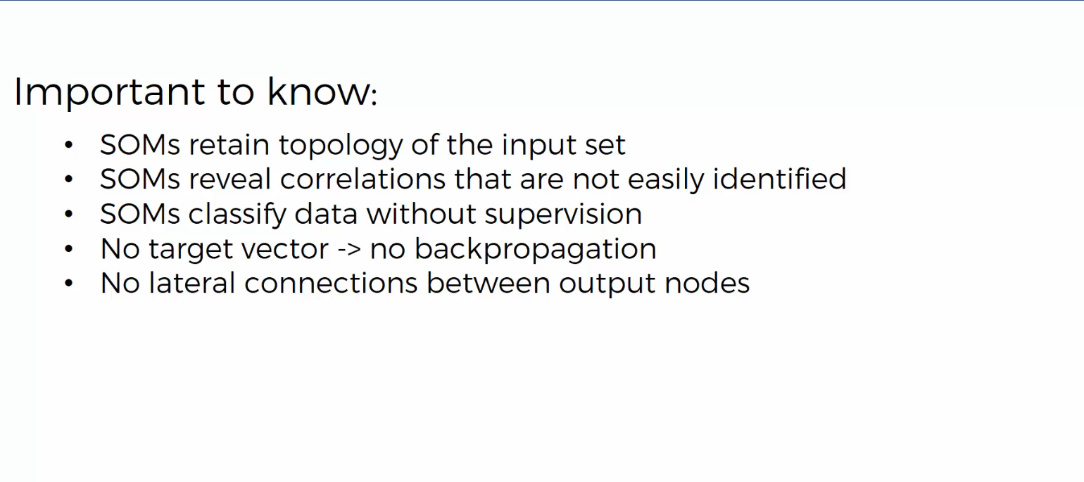

Unified Distance Matrix shows the distance between nodes on a self organizing map.

NOTE: The KMeans++ algorithm allows you to avoid the Random Initialization trap which can lead you to the wrong clusters.

The Within Cluster Some of S allows us to choose the right number of clusters.

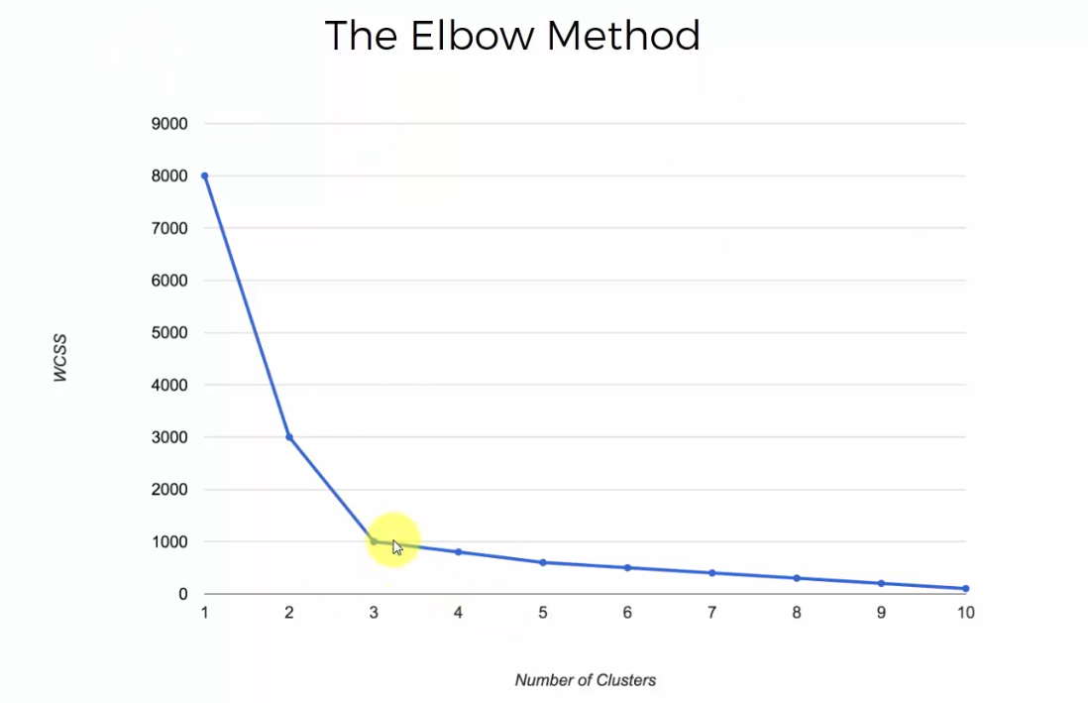

Just look for the elbow in your chart i.e. the point on your chart where the drop in WCSS is not as substantial but gradual.

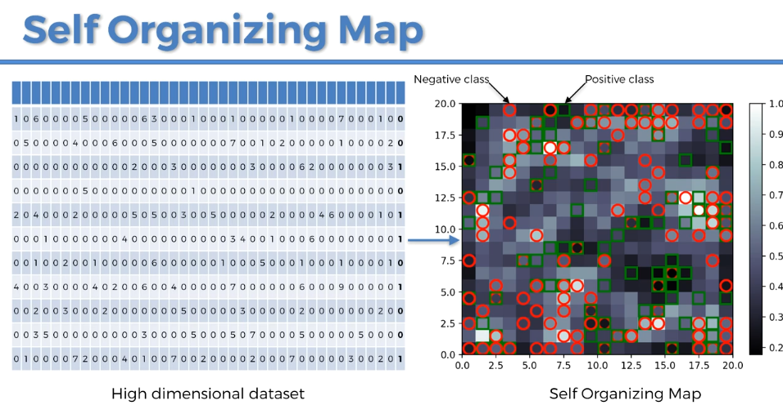

When using a SOM to detect frauds, they are the outliers. A fraud is defined by something far from the general rules. So the frauds are the outlying neurons in the 2D SOMs. To detect the outlying neuron you need the MID, the Mean Interneuron Distance of each neuron.

CTRL + i to get documentation in Spyder